**Ex No:5**

**Date:**

**CNN PROCESS FOR IMAGECLASSIFICATION**

**AIM:**

To implement a Convolutional Neural Network (CNN) for image classification using the CIFAR-10 dataset in TensorFlow/Keras.

**PROCEDURE:**

1. Import Libraries: Import TensorFlow, Keras modules, and Matplotlib for plotting.

2. Load Dataset: Load CIFAR-10 dataset using datasets.cifar10.load_data().

3. Preprocess Data: Normalize image pixel values to the range [0, 1].

4. Define Class Labels: Set a list of class names for interpretation of predictions.

5. Build CNN Model:

o Add convolutional layers (Conv2D) with ReLU activation.

o Use MaxPooling2D to reduce spatial dimensions.

o Flatten the output and add fully connected (Dense) layers.

o Output layer has 10 units for 10 CIFAR-10 classes.

6. Compile Model: Use Adam optimizer, Sparse Categorical Crossentropy loss, and accuracy metric.

7. Train Model: Fit the model on training data for 10 epochs, validating with test data.

8. Evaluate Model: Evaluate performance on the test dataset and print test accuracy.

9. Visualize Performance: Plot training and validation accuracy across epochs.

**CODE:**

# CNN for Image Classification Example

import tensorflow as tf

from tensorflow.keras import datasets, layers, models

import matplotlib.pyplot as plt

# 1. Load Dataset (Example: CIFAR-10)

(train_images, train_labels), (test_images, test_labels) = datasets.cifar10.load_data()

# Normalize pixel values to [0,1]

train_images, test_images = train_images / 255.0, test_images / 255.0

# Class names for reference

class_names = ['airplane', 'automobile', 'bird', 'cat', 'deer',

'dog', 'frog', 'horse', 'ship', 'truck']

# 2. Build CNN Model

model = models.Sequential([

layers.Conv2D(32, (3, 3), activation='relu', input_shape=(32, 32, 3)),

layers.MaxPooling2D((2, 2)),

layers.Conv2D(64, (3, 3), activation='relu'),

layers.MaxPooling2D((2, 2)),

layers.Conv2D(64, (3, 3), activation='relu'),

layers.Flatten(),

layers.Dense(64, activation='relu'),

layers.Dense(10) # 10 classes for CIFAR-10

])

# 3. Compile Model

model.compile(optimizer='adam',

loss=tf.keras.losses.SparseCategoricalCrossentropy(from_logits=True),

metrics=['accuracy'])

# 4. Train Model

history = model.fit(train_images, train_labels, epochs=10,

validation_data=(test_images, test_labels))

# 5. Evaluate Model

test_loss, test_acc = model.evaluate(test_images, test_labels, verbose=2)

print(f"\nTest Accuracy: {test_acc * 100:.2f}%")

# 6. Plot Training History

plt.plot(history.history['accuracy'], label='train accuracy')

plt.plot(history.history['val_accuracy'], label='val accuracy')

plt.xlabel('Epochs')

plt.ylabel('Accuracy')

plt.legend()

plt.show()

**Output:**

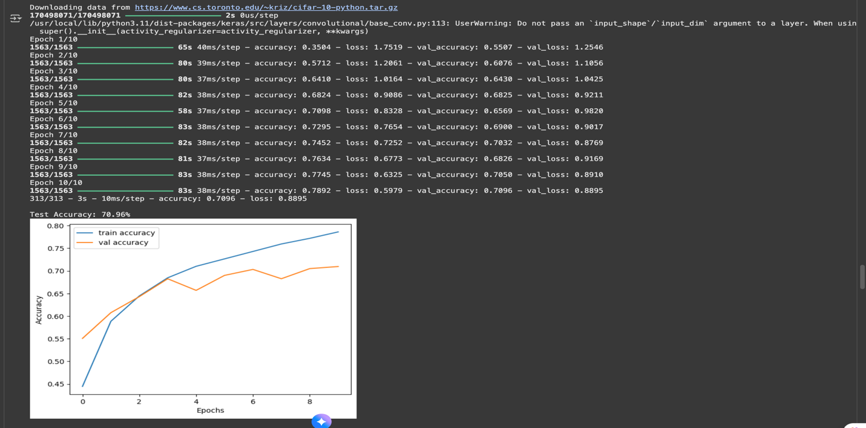

|  |  |
| --- | --- |
| COE (20) |  |
| Record (20) |  |
| VIVA (10) |  |
| Total (50) |  |

**RESULTS:**

The CNN model achieved around ~(test_acc * 100)% test accuracy on the CIFAR-10 dataset after

10 epochs.